Experiment 1

Installation of Cygwin

1. Go to site <http://www.cygwin.com/> to download installer

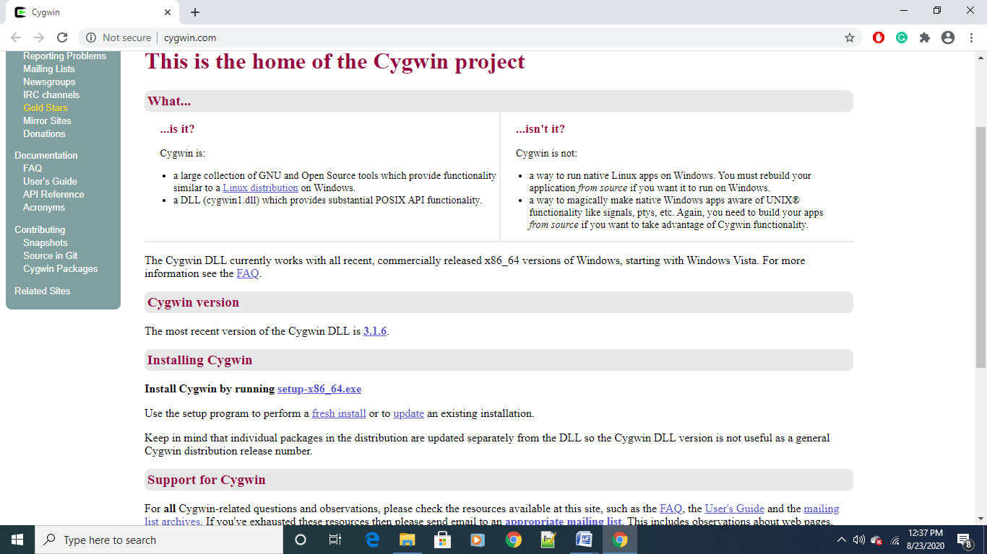

2. When installer is downloaded run it

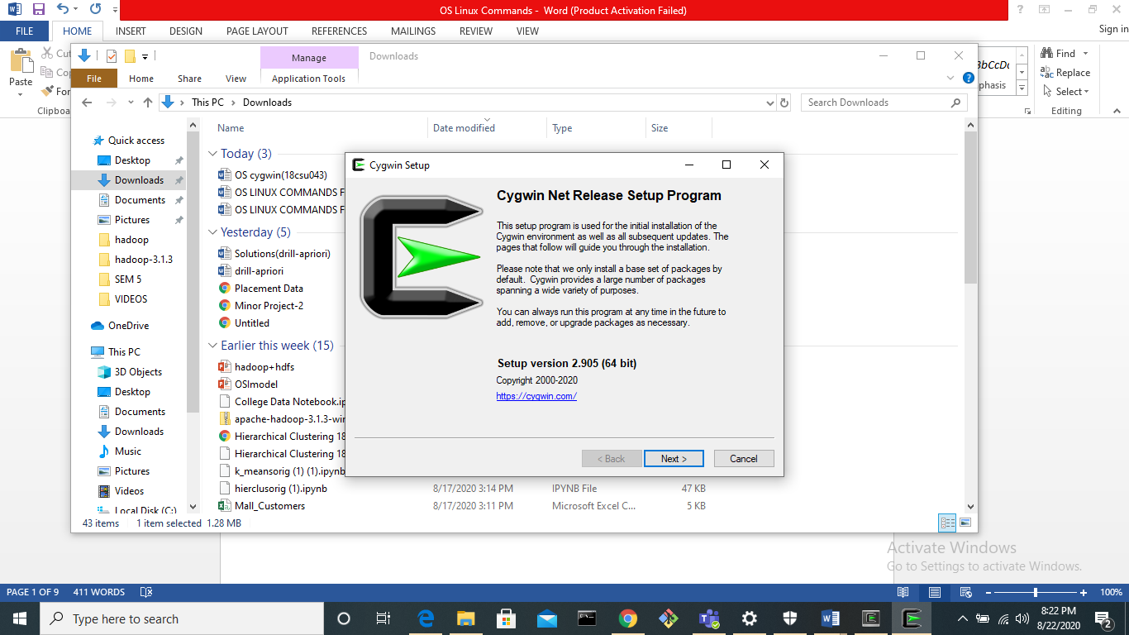

3. Click on first option and then next

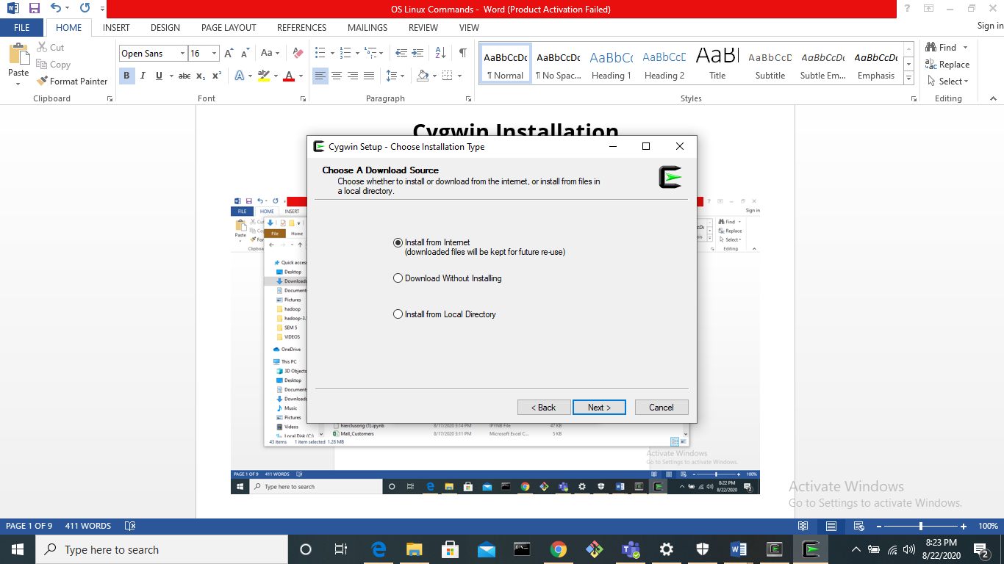

4. Enter the path in which you want to install the software and click next

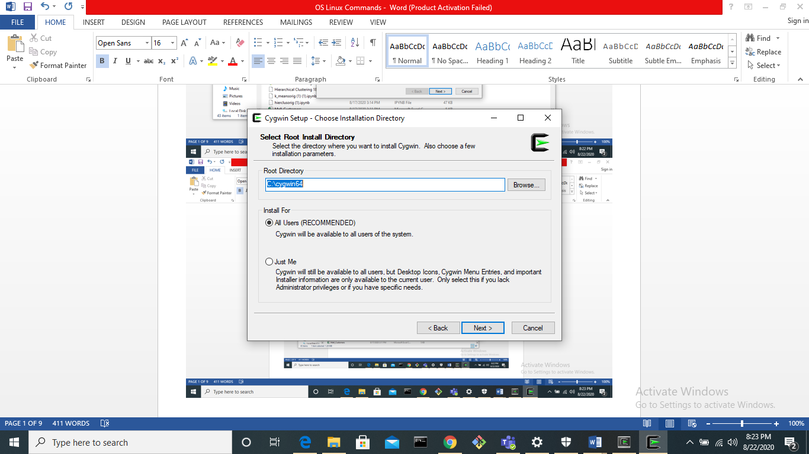

5. Select your desired network setting and then next

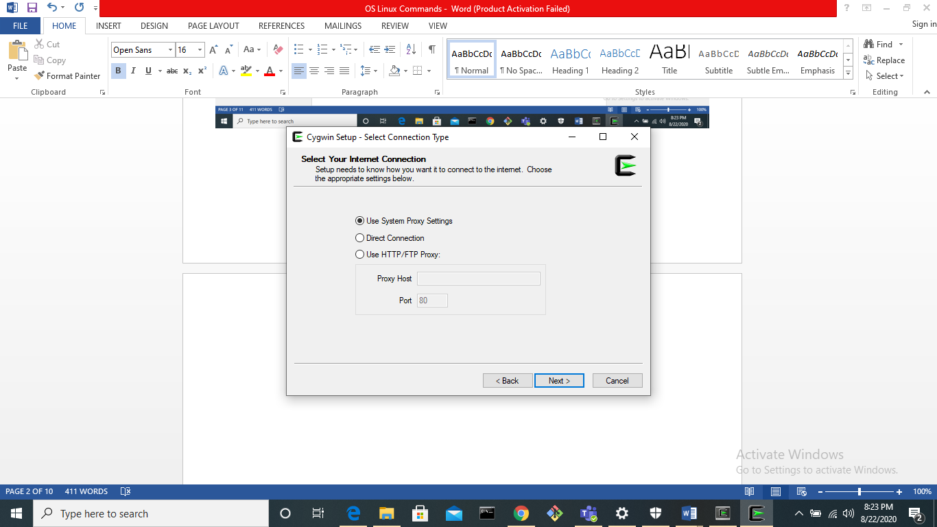

6. Click on third site and then next

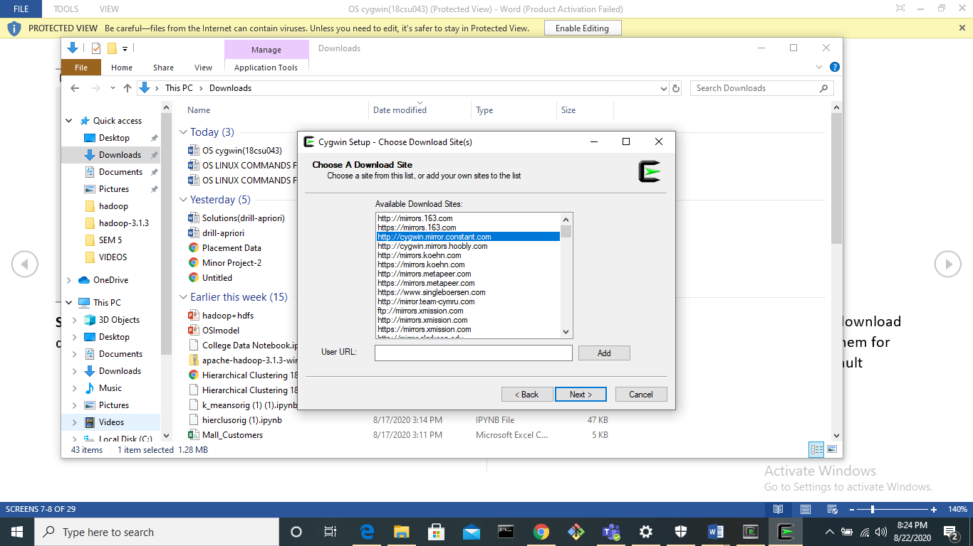

7.Your setup will be downloaded

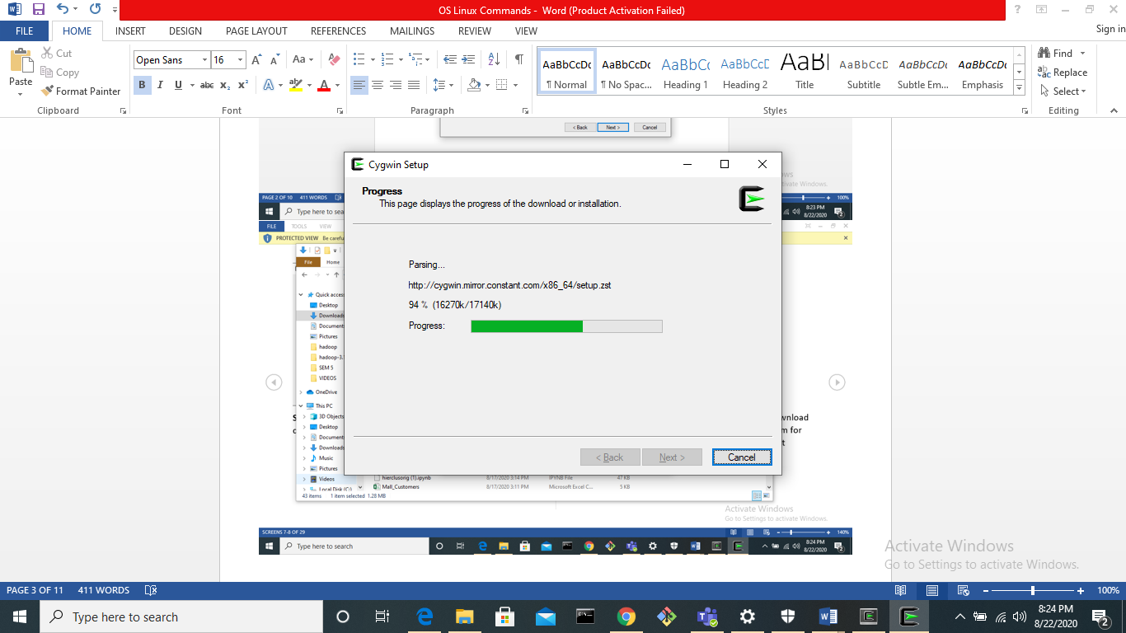

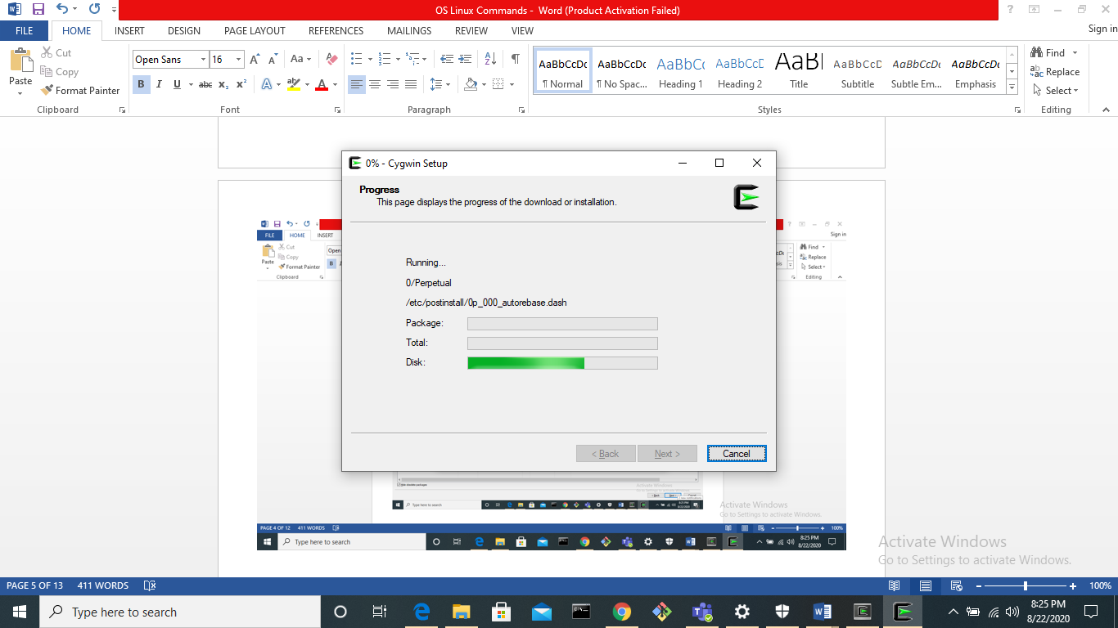

Experiment - 2

Basic Linux Commands

18csu004

1. **pwd** – To know current directory

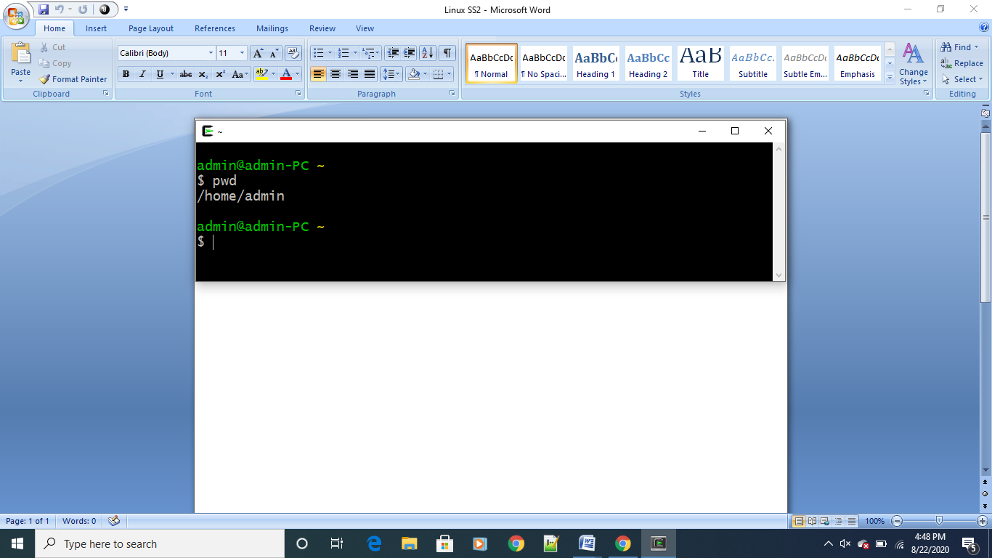

**2. man** – it is used to open help dialogue box about a command

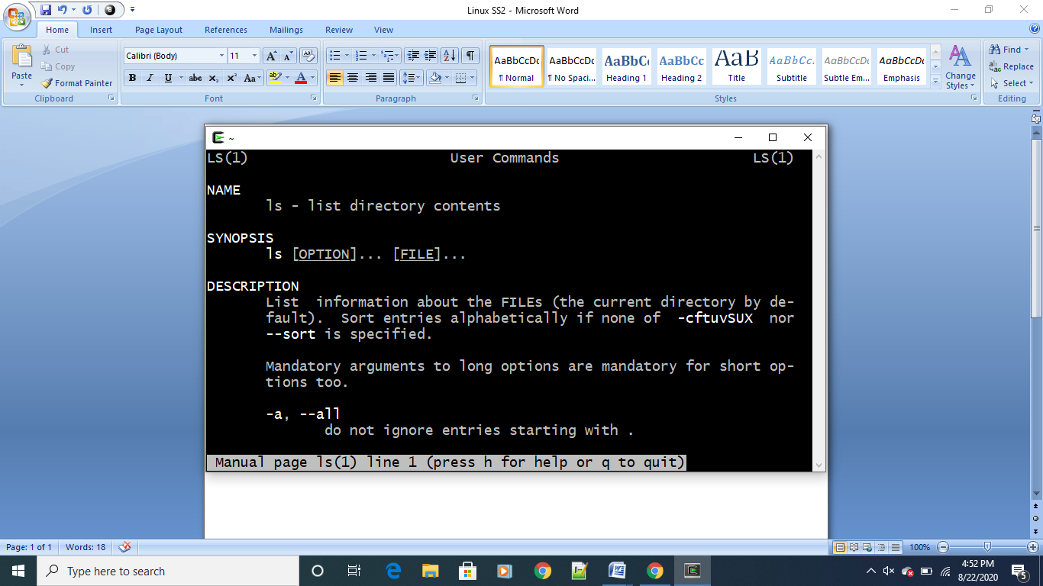

**3. ls** – list of files in current directory

**3.1 ls –a** : Hidden files are also listed

**3.2 ls –r :** Listed files are shown in reverse order

**3.3 ls –l :** List of files with its permission are displayed

**3.4 ls – I :** list the files according to its index

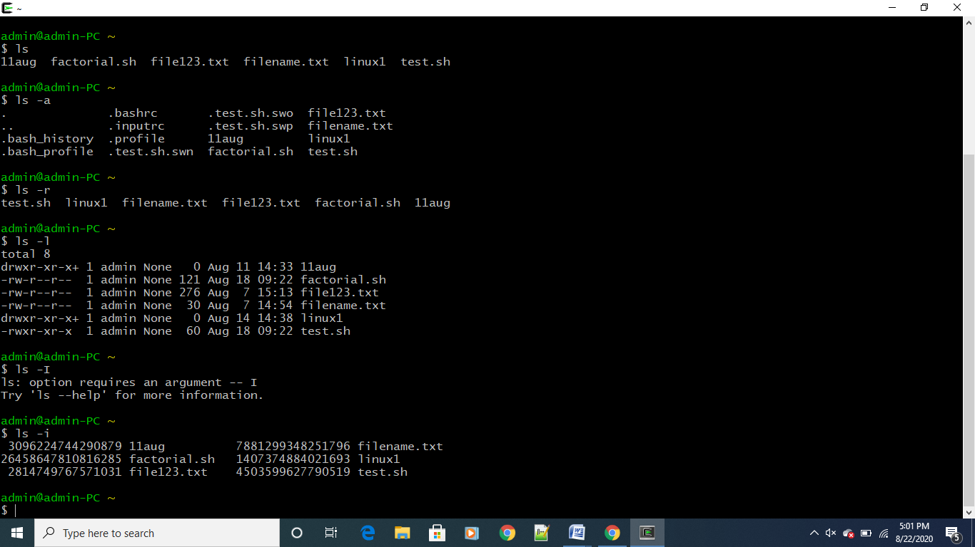

**4. mkdir –** This command is used to make a new directory

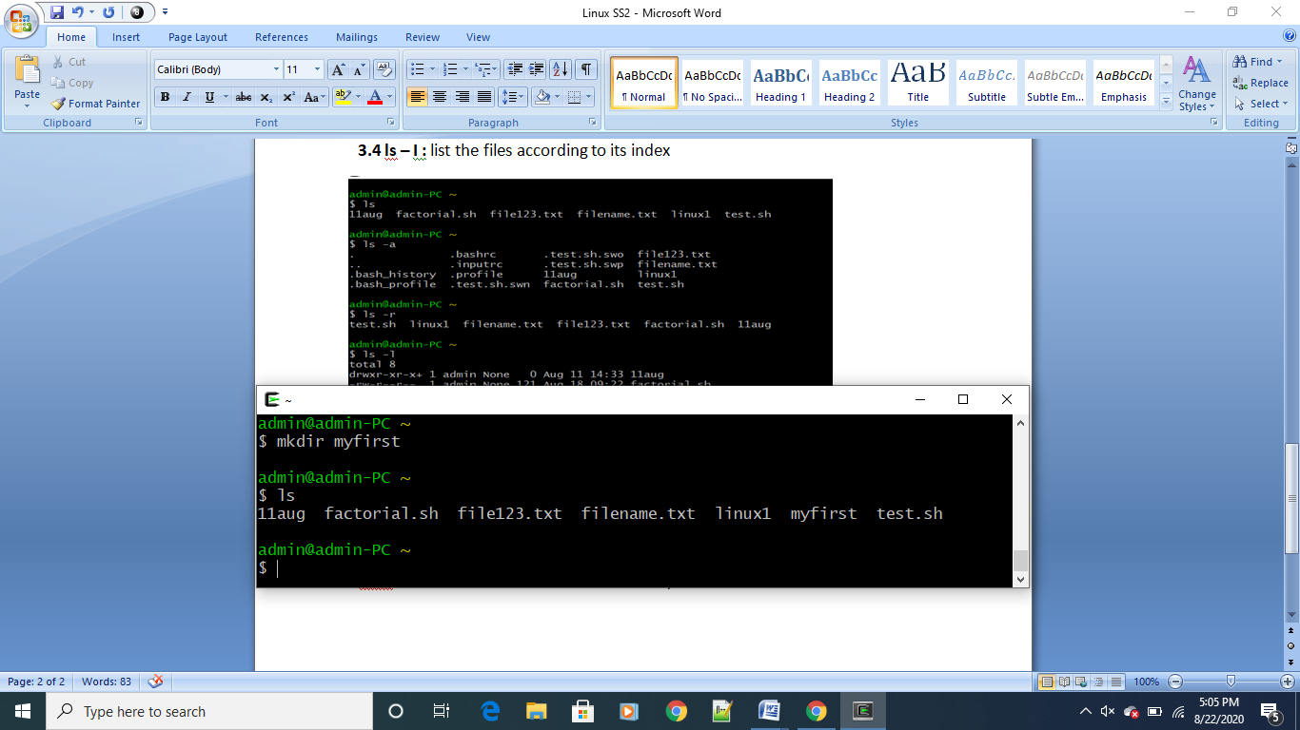

**5. cd –** This command is used to go into a directory

**5.1 cd ..** : This is used to go into previous directory

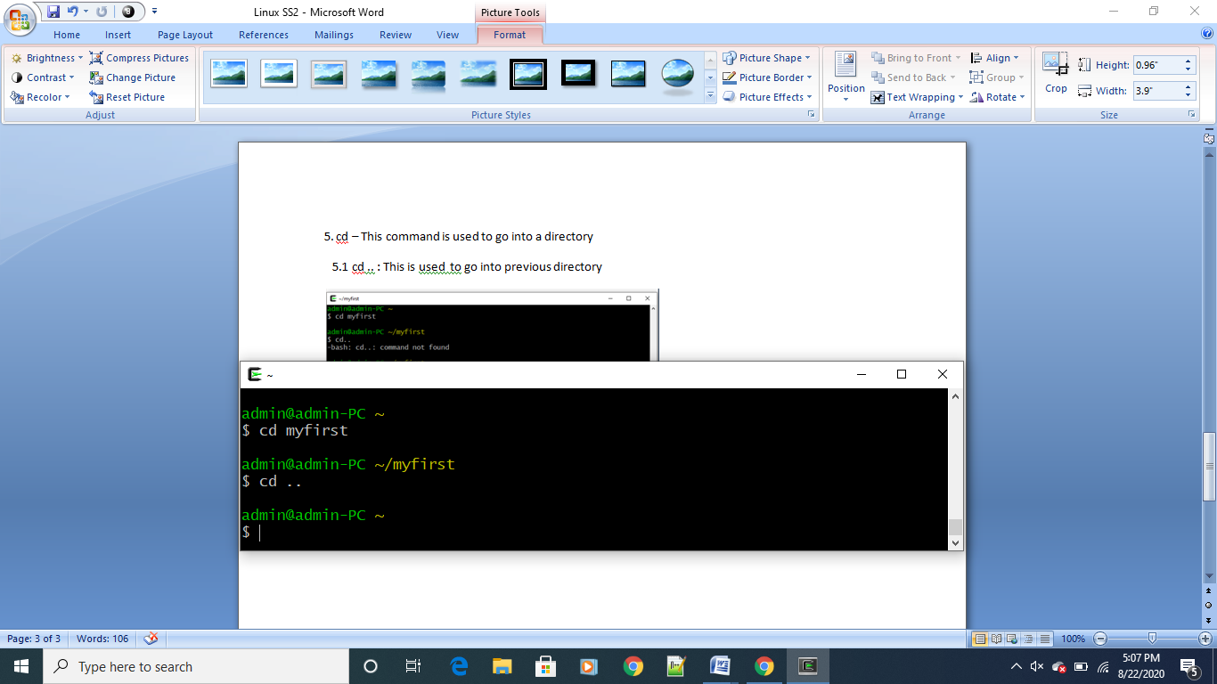

**6. cat > filename.txt -** makes a new file in current directory

**Cat filename.txt –** displays content of file

**Cat filename.txt > filename.txt –** copies content of first file in second file

**Cat >> filename.txt –** appends the text in file

**Cat filename.txt >> filename.txt –** appends the text in file 1 to 2

**Cat -b filename.txt –** gives index to contents in file

**Cat –e filename.txt –** gives a dollar sign at end of each sentence

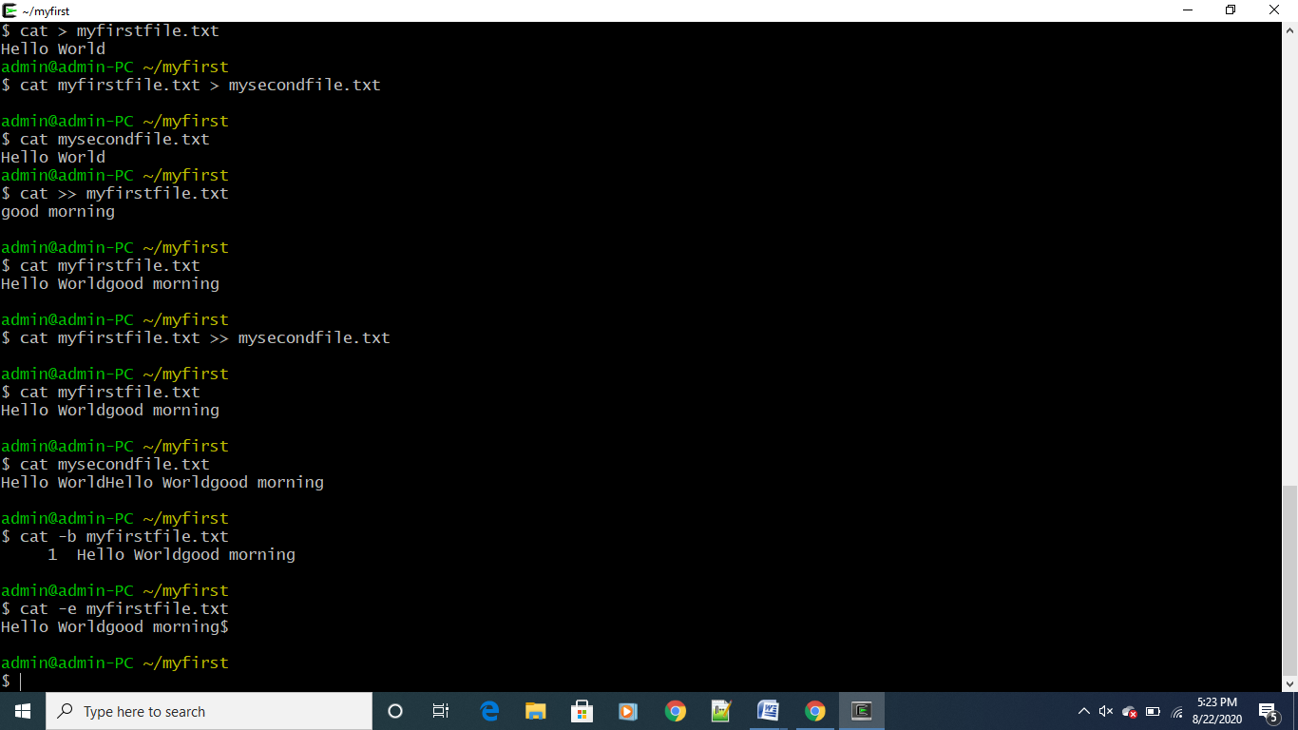

**7. echo –** it is used to append data into a file

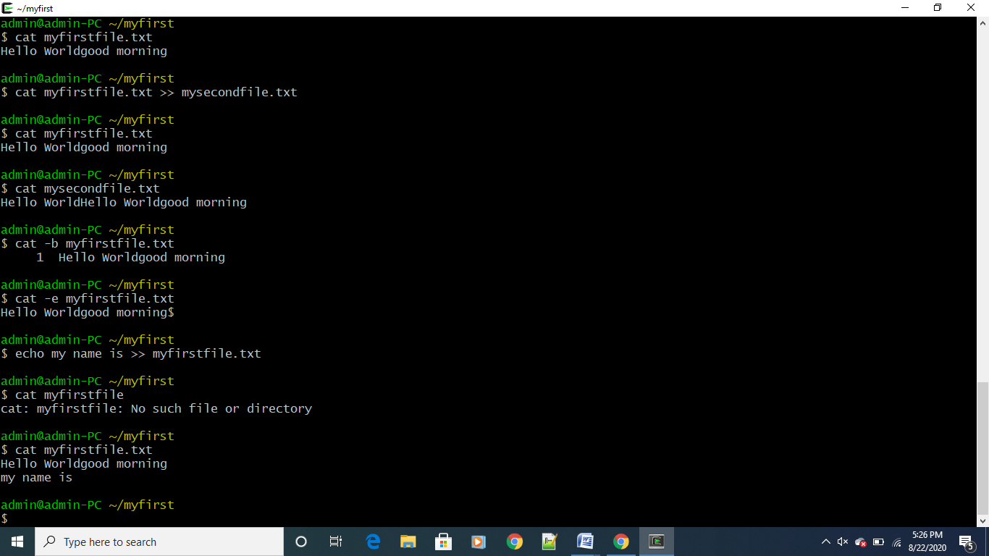

**8. mv –** moves a file from one location to another

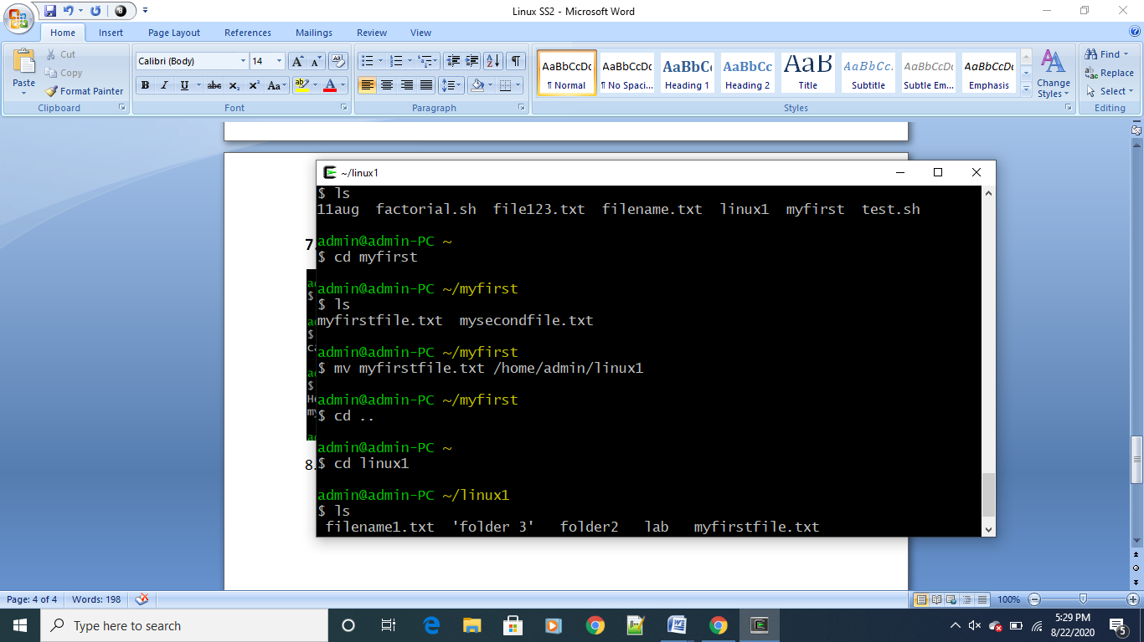

9. **cp filename.txt filename2.txt –** copies the content of file1 and make another file file2 and past in it

**cp filename.txt dir_location –** copies filename and pastes in the location

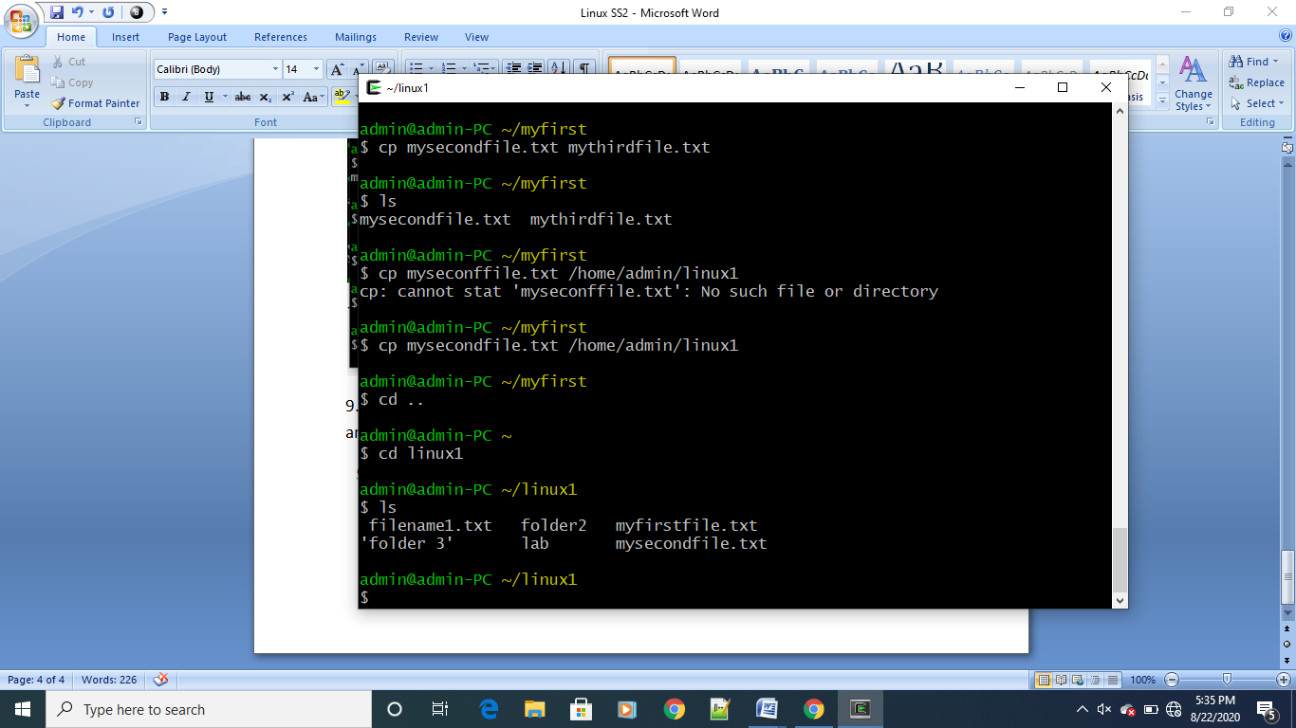

**10. file –** gives description about file

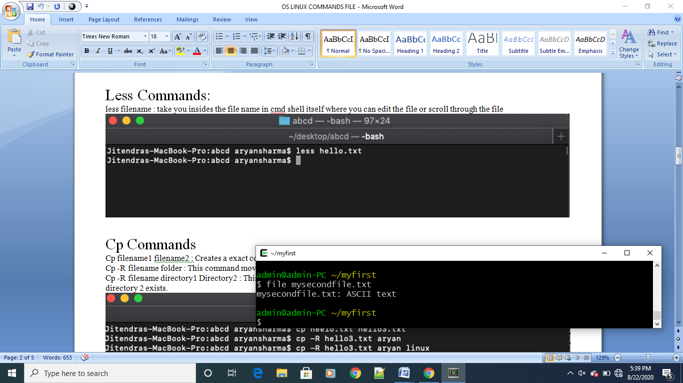

**11. touch –** creates a new file

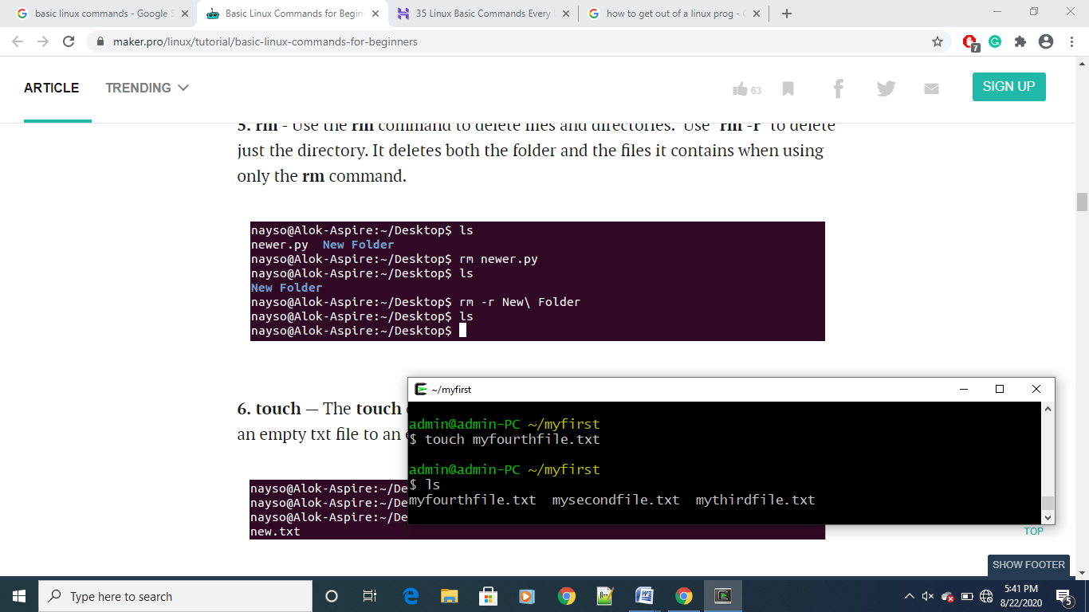

**12. grep “word” file.txt –** this command is used to find a word in a file

**Grep –iv “word” file.txt** – displays lines which does not contain the word

**Grep –c “word” file.txt –** displays no of lines “word” is present in file

**Grep –n “word” file.txt –** displays the index of line which contains “word”

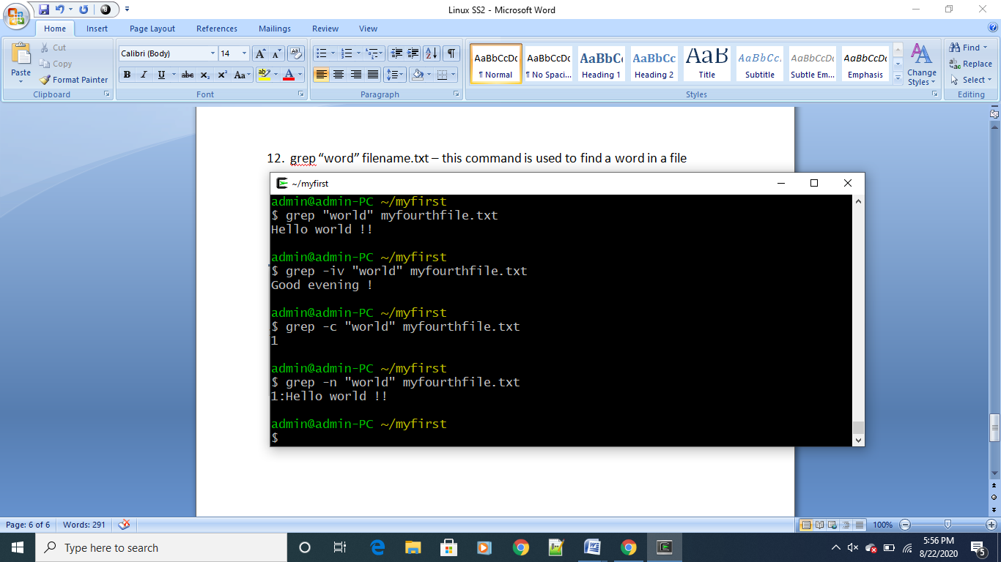

**13. find –** searches for files and directories

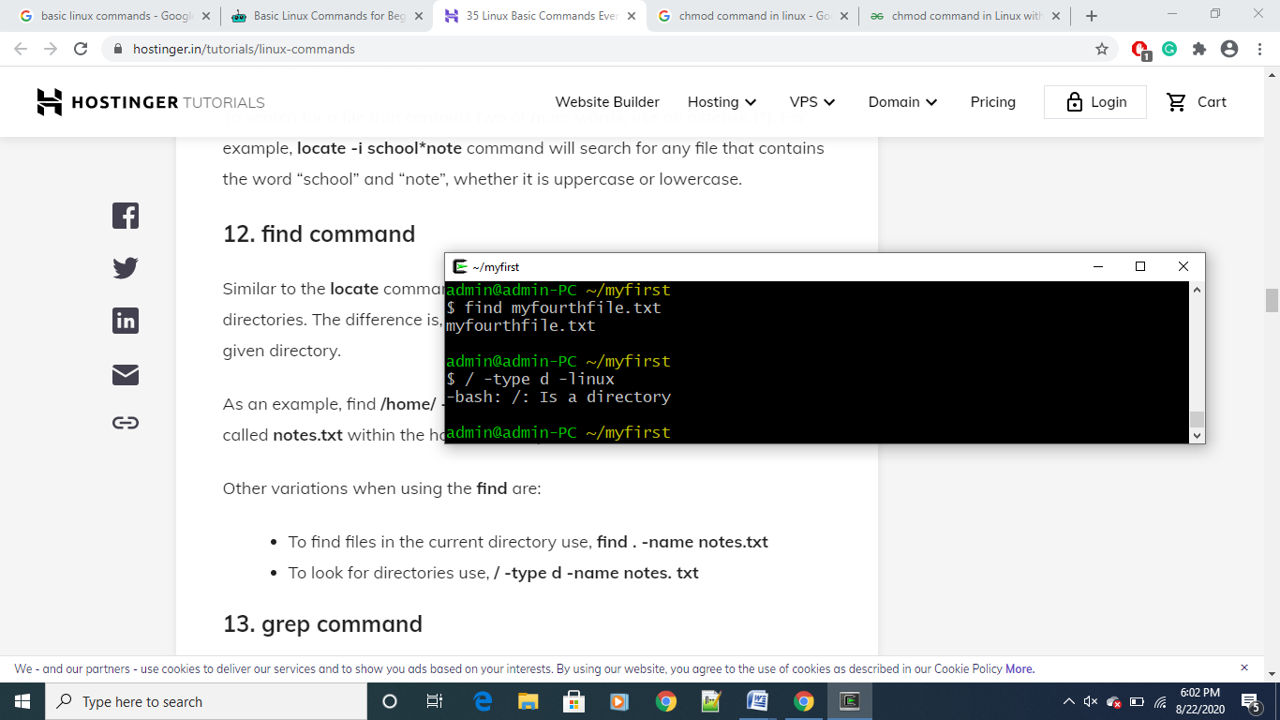

**14. alias –** This is used to give another name to a command

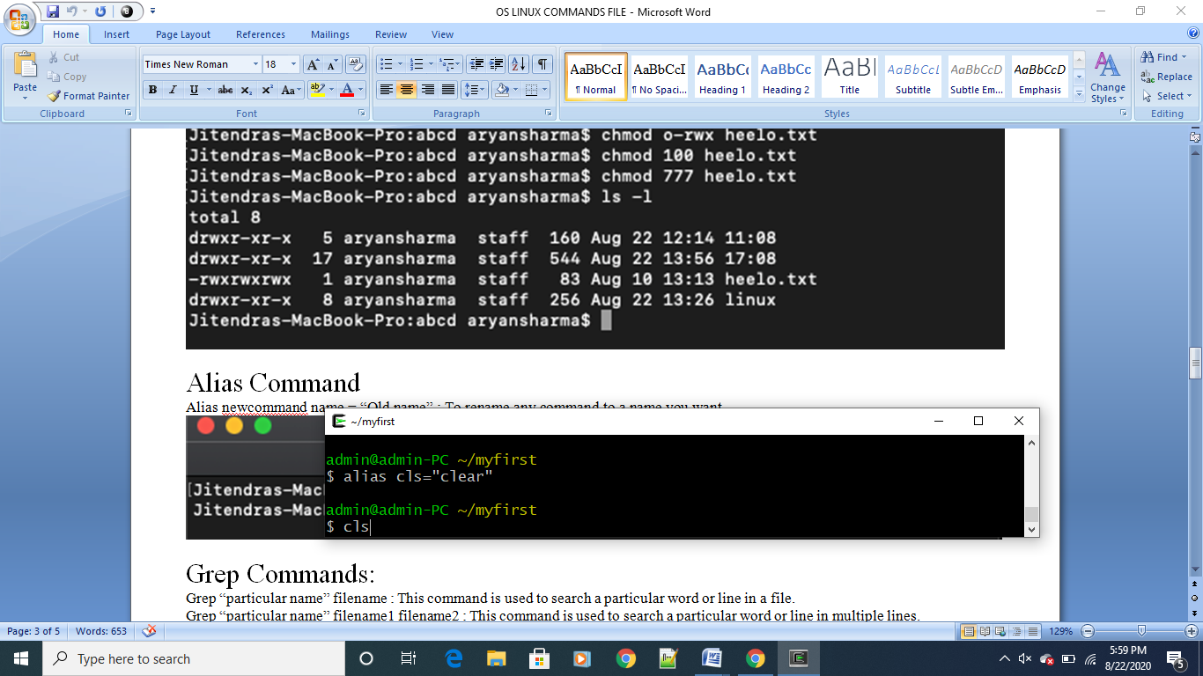

**15 . Head and Tail commands –** used to display first n or last n no of lines of a file

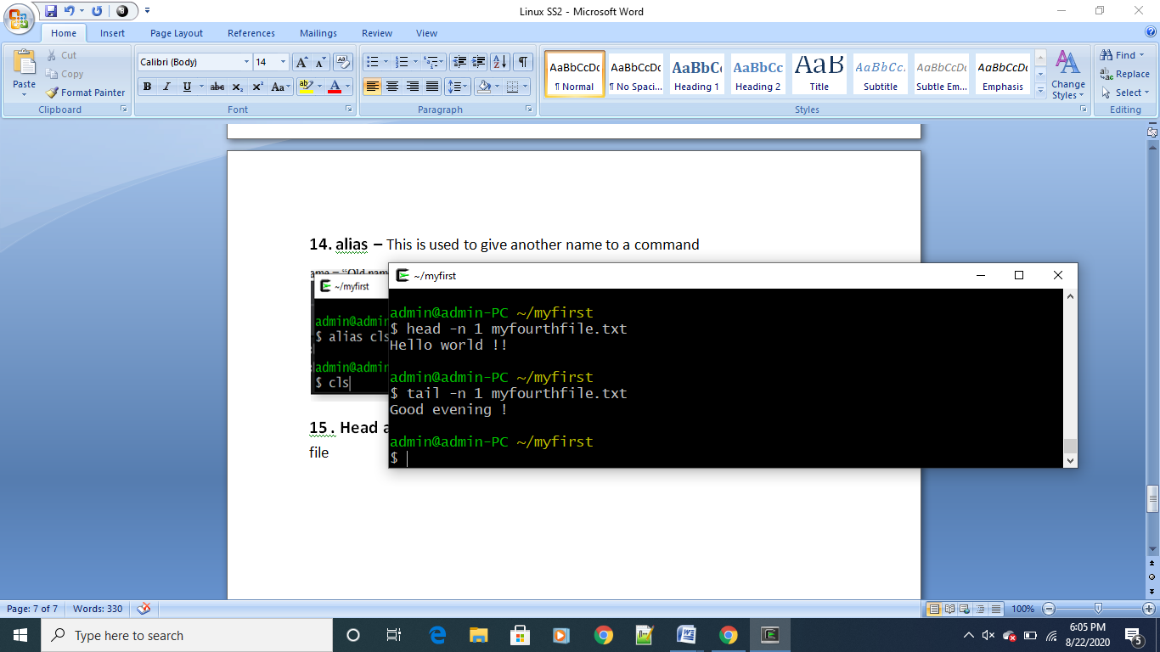

**16. df –** used to get the data on disk usage

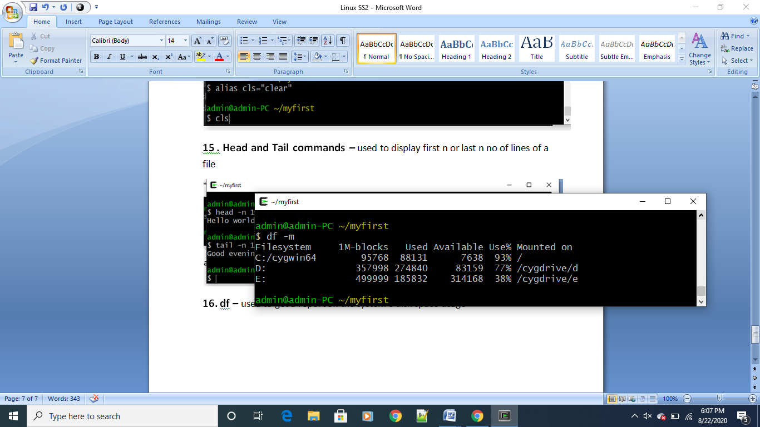

**17. du –** used to see how much space a file or a directory takes

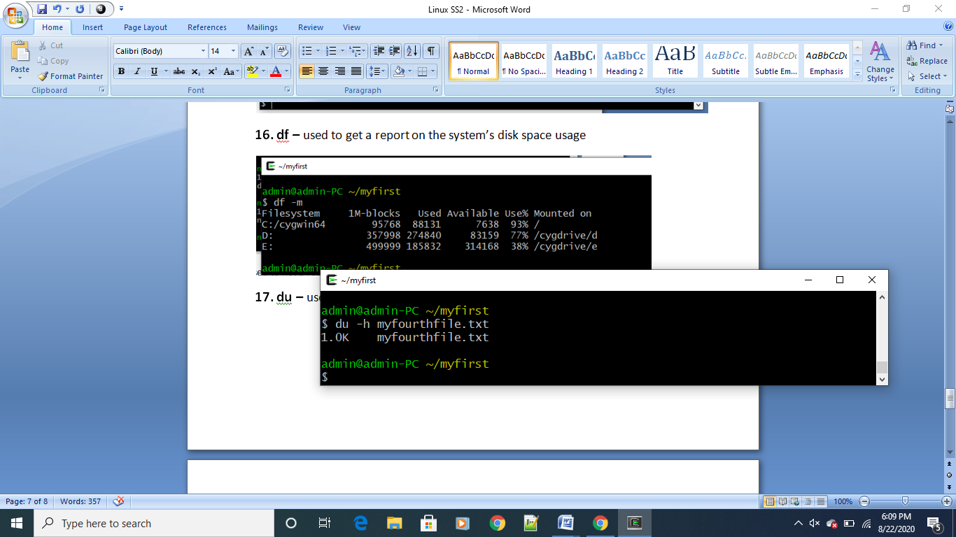

**18. jobs –** display all current jobs running

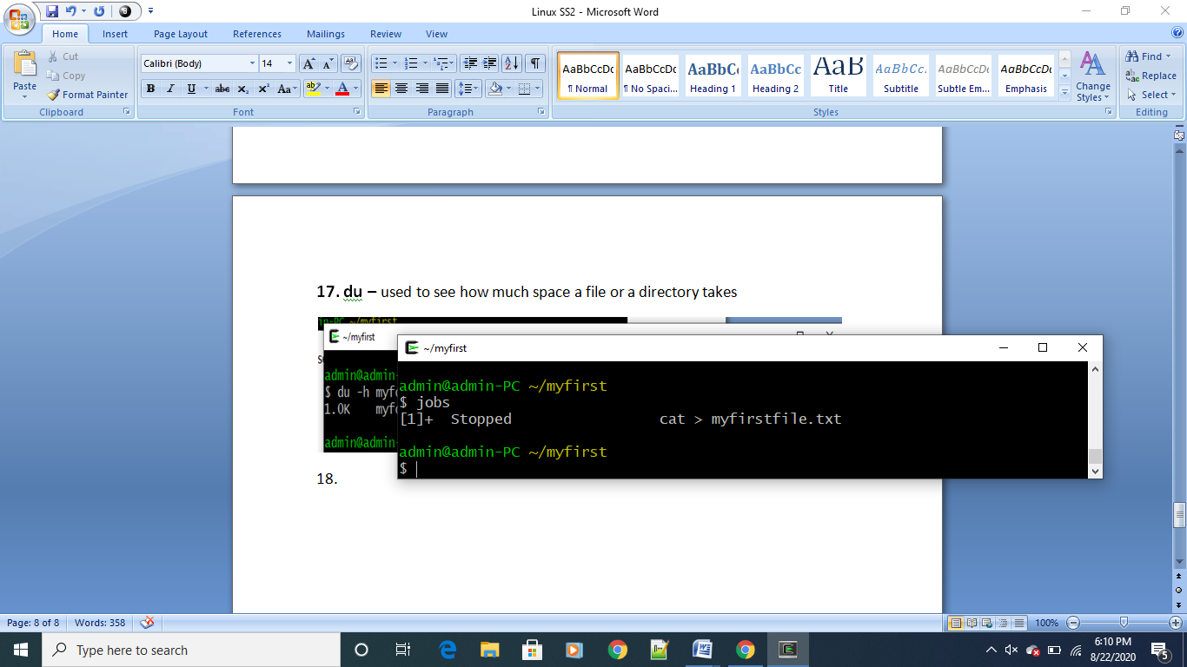

**19. chmod –**

**Chmod u=r :** user can only read the file and not write the file.

**Chmod u=rw :** user cannot search the directory

**Chmod o-wx:** removes the read , write and execute permission for everyone except owner.

**Chmod a-x:** this command gives execute permission for all users

**Chmod 644 filename :** gives read and write only permissions to everyone

**Chmod 750 filename**: gives the owner read, execute and write permission, to only group members

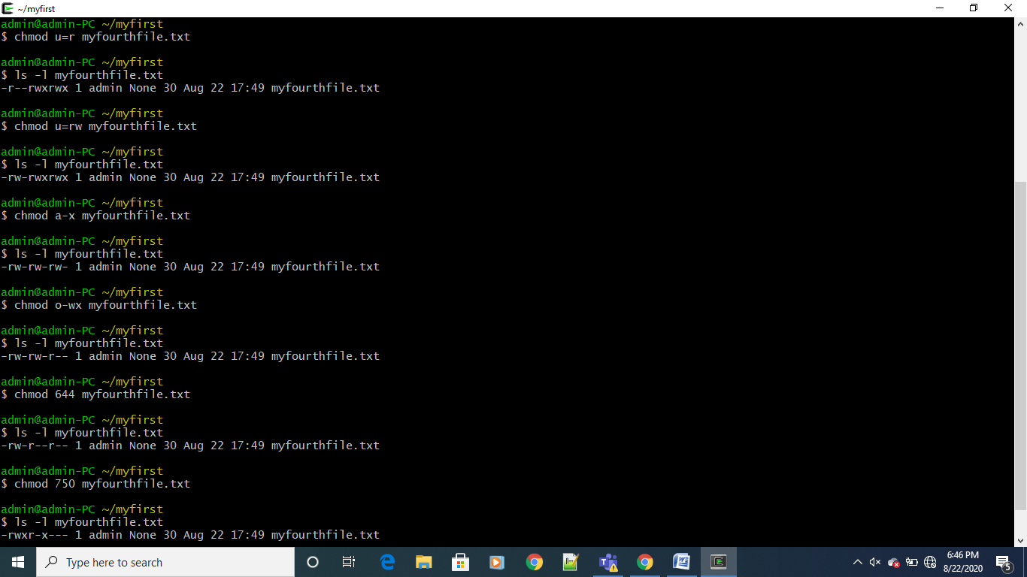

**20. diff -** compares the contents of two files line by line and outputs the lines that do not match

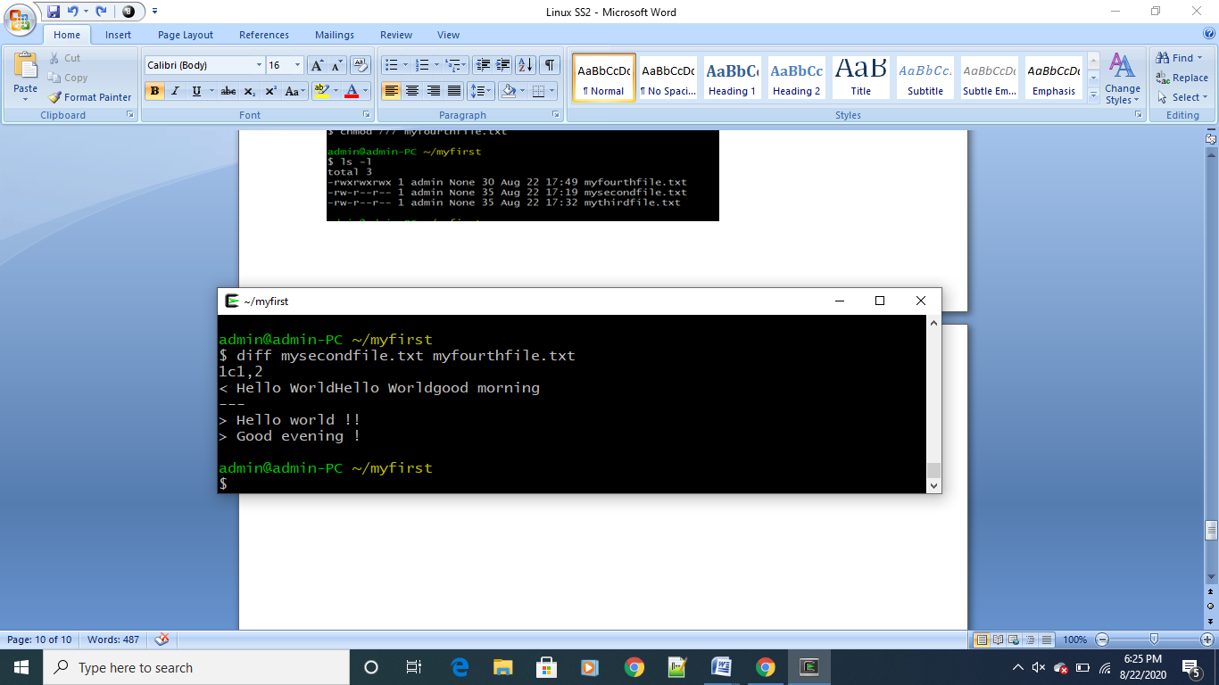

**21. ps –** this command outputs current process

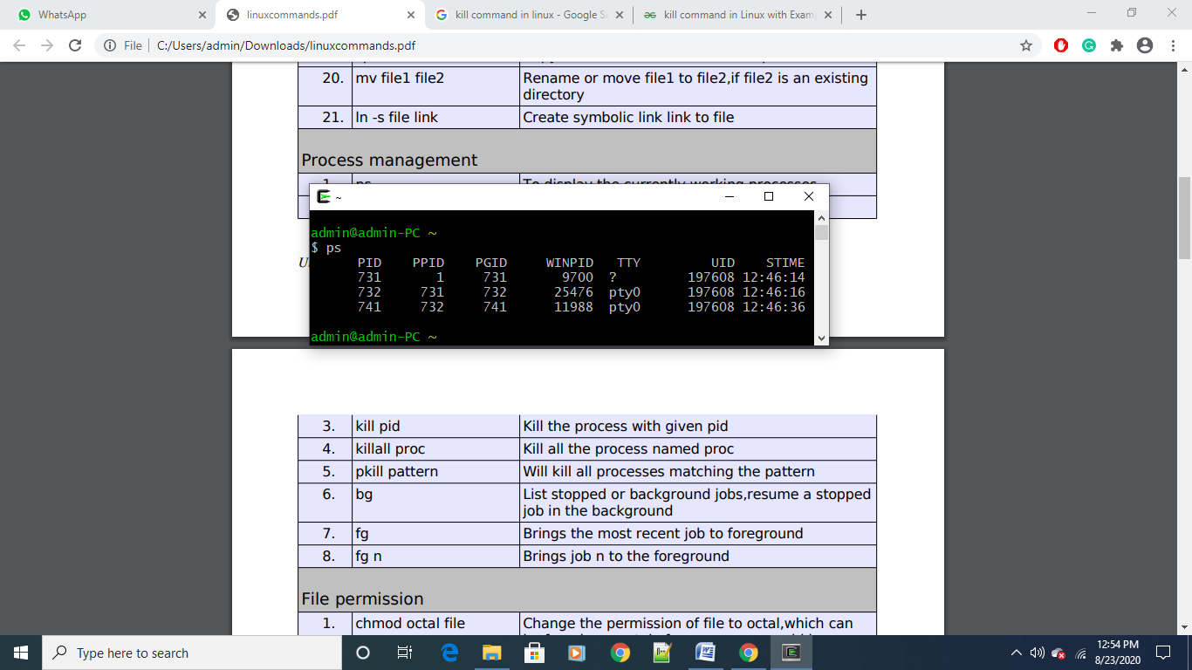

**22. Date –** displays the current date and time

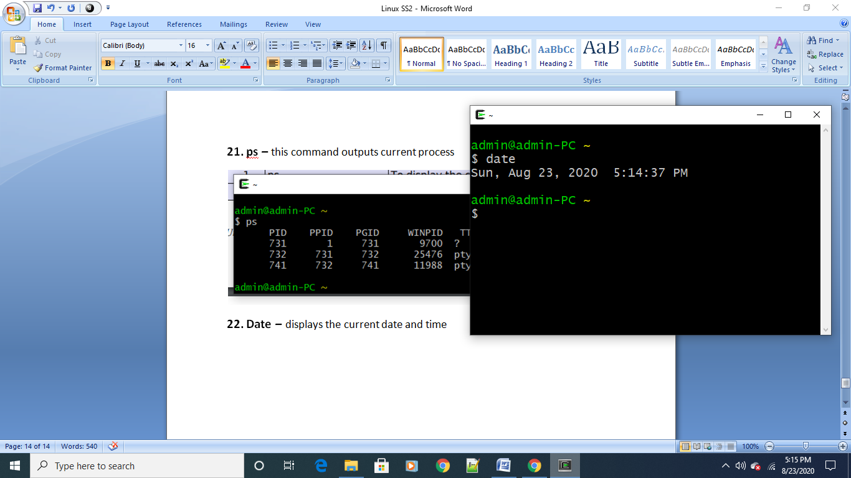

**23. cal –** shows the current month calendar

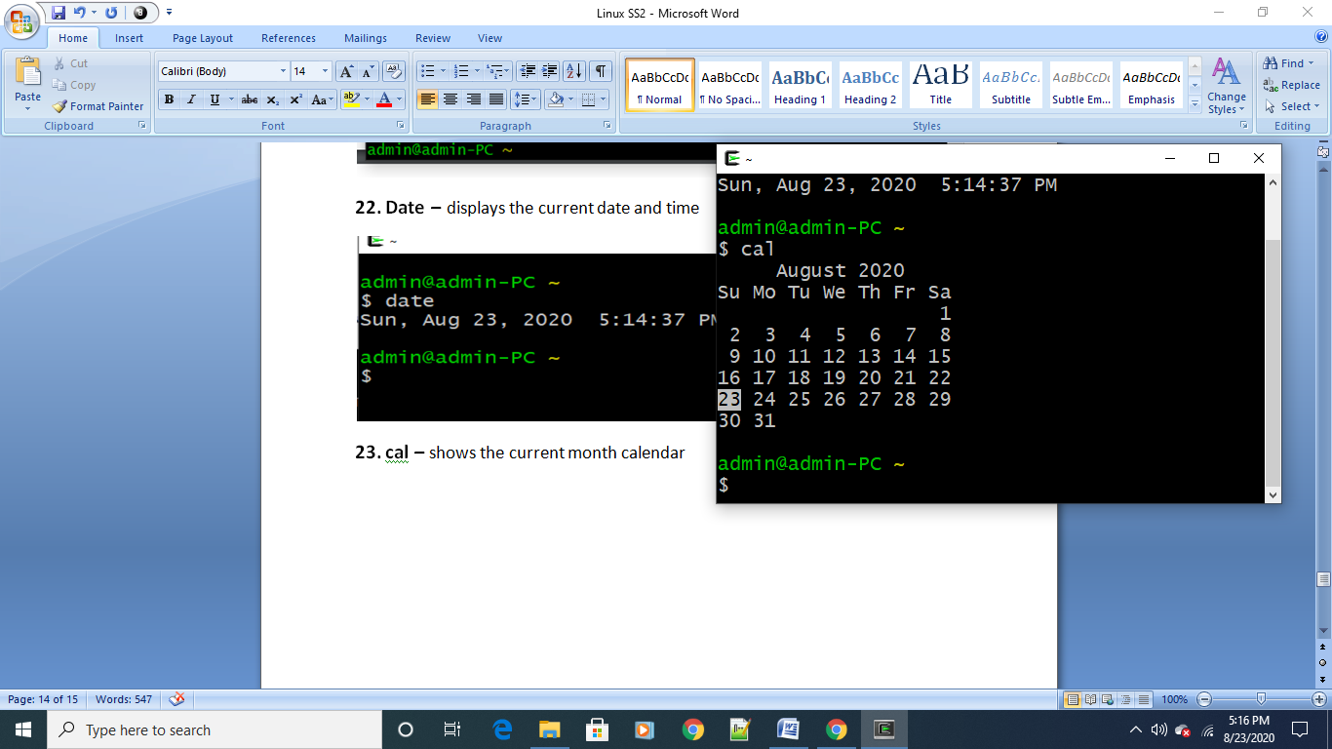

**24. whoami –** outputs who is logged in

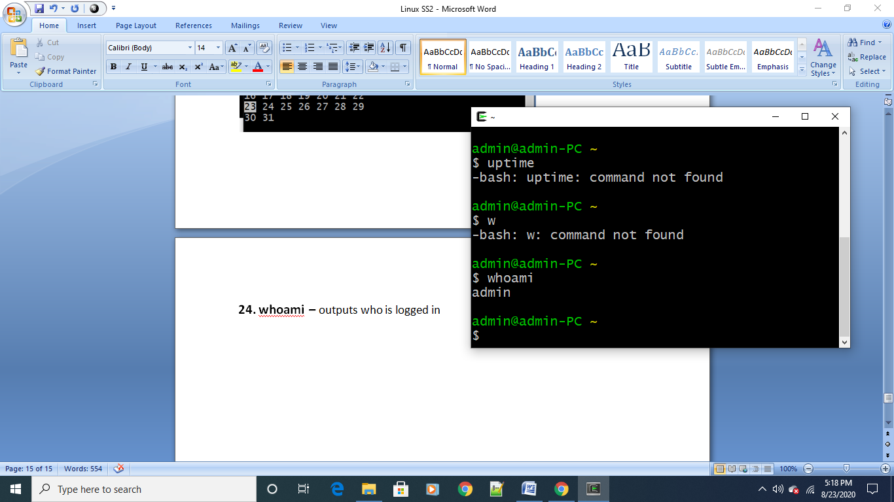

**25. uname –a –** displays information about kernel

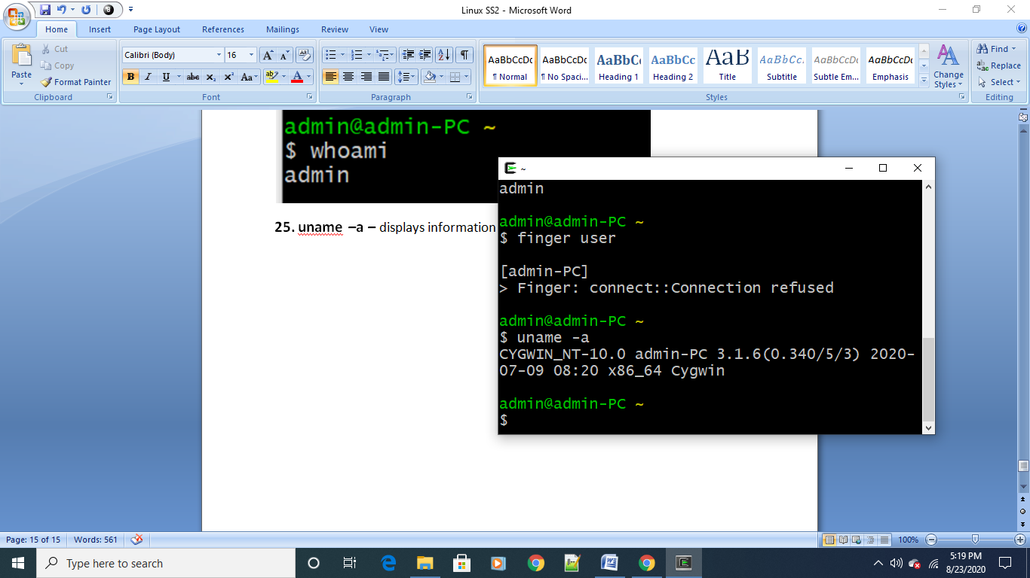

**26. cat /proc/cpuinfo –** outputs information about cpu

